SQL Queries:

Inner join: Common in both tables

Left Join: All on left table and matched records from right table

Right Join: All on right table and matched records from left side

Full Outer Join: All records when there is a match in either left (table1) or right (table2) table records.

**SQL join: where clause vs. on clause ?**

* Does not matter for inner joins
* Matters for outer joins

a. WHERE clause: **After** joining. Records will be filtered after join has taken place.

b. ON clause - **Before** joining. Records (from right table) will be filtered before joining. This may end up as null in the result (since OUTER join).

[**https://stackoverflow.com/questions/354070/sql-join-where-clause-vs-on-clause/20981676#20981676**](https://stackoverflow.com/questions/354070/sql-join-where-clause-vs-on-clause/20981676#20981676)

**LEFT JOIN vs. LEFT OUTER JOIN in SQL Server ?**

Here's a list of equivalent syntaxes:

A LEFT JOIN B A LEFT OUTER JOIN B

A RIGHT JOIN B A RIGHT OUTER JOIN B

A FULL JOIN B A FULL OUTER JOIN B

A INNER JOIN B A JOIN B

Select * from Employee where employee_name IS NULL(Always use IS NULL and not = NULL)

[Data Types](https://www.w3schools.com/sql/sql_datatypes.asp):

Char(length) – stores a value of given size always

Varchar(length) – stores a value of any length less than the given size

BLOB - For BLOBs (Binary Large Objects). Holds up to 65,535 bytes of data

SQL Commands- <https://www.interviewbit.com/tutorial/sql-commands/#sql-commands>

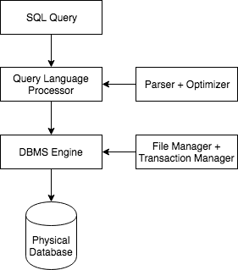

Communication when multiple servers/players involved

Sharding in detail - <https://medium.com/@Pinterest_Engineering/sharding-pinterest-how-we-scaled-our-mysql-fleet-3f341e96ca6f> **(MUST READ)**

<https://en.wikipedia.org/wiki/Paxos_(computer_science)> (yet to read)

Different Normalization Techniques:

**Mongo DB:**

mongod is the "Mongo Daemon" it's basically the host process for the database. When you start mongod you're basically saying "start the MongoDB process and run it in the background". mongod has several default parameters, such as storing data in /data/db and running on port 27017.

mongo is the command-line shell that connects to a specific instance of mongod. When you run mongo with no parameters it defaults to connecting to the localhost on port 27017. If you run mongo against an invalid machine:port combination then it will fail to connect (and tell you as much).